# SINGLE LED
Vedant kubde
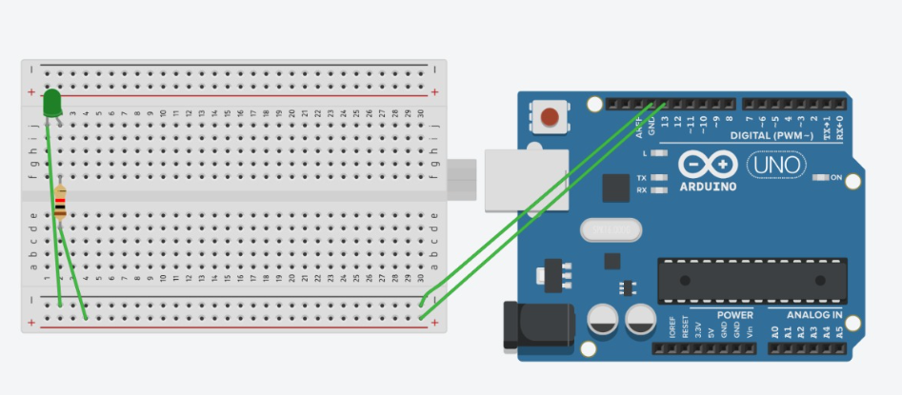
// C++ code
//
void setup()
{
pinMode(LED_BUILTIN, OUTPUT);
}

void loop()
{
digitalWrite(LED_BUILTIN, HIGH);
delay(1000); // Wait for 1000 millisecond(s)
digitalWrite(LED_BUILTIN, LOW);
delay(1000); // Wait for 1000 millisecond(s)
}

OBSERVATION:
The Led turns ON for 1 second and OFF for 1 second repeteadly.

